我知道测试 Kd 时，所用 DNA 应该小于 Kd 100 倍以上（为什么， 如何推出？），我测的我的蛋白Kd大概是100 nM , 用的 DNA小于1 nM,, 所得曲线如图：

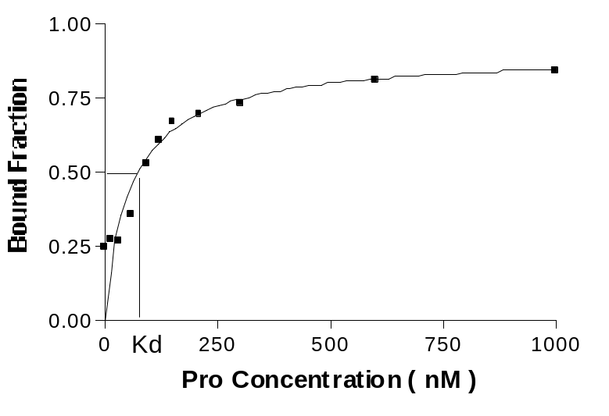

Kd 为1／2 DNA 被结合时蛋白的浓度。我的问题是： 假设我用 10 nM, 或 100 nM
DNA, 还可以测Kd 吗？这样得到的曲线会是什么样的？你可不可以把推导过程，不同 DNA浓度应该得到的理论曲线发给我，谢谢。其实我也在网上查了下，因为没有找到针对性很强的，所以还是不太明白，才想到要来麻烦你。

2009-07-14 Kan's answer:

For binding reaction:
A + B = AB (in your case: A is DNA and B is protein)

there is:
[A]free * [B]free = [AB]*Kd (1)
[A]free + [AB] = [A]total (2)
[B]free + [AB] = [B]total (3)

let
a=[A]total/Kd (4)
b=[B]total/Kd (5)

bring (2)~(5) into (1), get
(a*Kd-[AB])*(b*Kd-[AB])=[AB]*Kd (6)

solve (6), get
[AB]/[A]total = [AB]/(a*Kd) = ((a+b+1)-((a+b+1)^2-4*a*b)^0.5)/(2*a) (7)

the left side of (7) is the y-axis of your binding experimental curve; the x-axis ([B]total) can be replaced by b with the units of “times of Kd”. So I can write a simple program to simulate the binding curves with fixing different a from 1e-5 to 1e4 (i.e., [A]total from 0.00001*Kd to 10000*Kd):

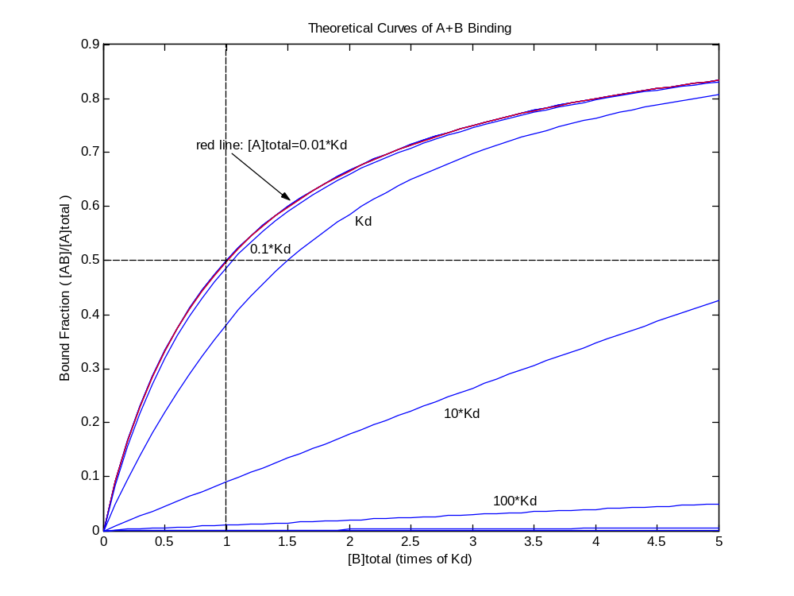
above figure can answer all your questions:
- why [A]total should <0.01*Kd
- how about higher [A]total will be

Actually, [A]total=0.1*Kd give a good enough approximation estimate of Kd. For higher [A]total (<10*Kd) also can be used to calculate Kd, but the ½ rule should be changed.

